
An der Hoelle 31
A-1100 Vienna / Austria
Phone: +43-1-6894700-0
Fax: +43-1-6894700-40
Email: office@demmel.com
Internet: www.demmel.com

Press Release
demmel products gmbh
Java on a Chip (JoC) – Professional JoC Module on an area of only 24x36 mm
Vienna, February 26, 2019 – demmel products presents Java on a Chip (JoC) for the first time at this year’s embedded world. This Java-programmable controller is qualified for a broad range of smart industrial applications. The JoC Module is designed for direct integration into the application’s hardware. For application development demmel products has designed the Javaino reference board alongside with the freely available JoC Manager. The IDE contains a complete Java development environment for editing, compiling and debugging of applications.
JoC enables developers to realize applications comfortably and with minimized efforts in an object oriented high-level language. The chip is placed on the JoC Module which can be directly soldered into the application hardware via SMT or 2 mm pin headers. JoC offers a wide range of interface options, among them digital and analog I/Os, 2x RS-232 (TTL), PWM I/Os, I²C, SPI and a keyboard interface. A/D- and D/A converters as well as a battery backed real time clock are also available. The Javaino reference board is extendable with the well-known “shields“.
Applications are programmed in the JoC Manager which is an intuitive IDE in the most modern windows layout. The freely available JoC Manager contains a complete Java development environment. This allows convenient editing of the Java code, compiling and remote source code debugging. Such features are usually only found in expensive high-level IDEs. The chip’s USB interface represents a distinctive feature which facilitates developers’ work: It is used to upload and execute the Java application directly on the chip. Source code remote debugging and console access are performed on the same USB interface at the same time. Common features such as breakpoints and variable inspection are included in the debugger. There is no additional hardware or software necessary.
The entire development and debug environment is set up within a few minutes by simply installing the JoC Manager.
At the embedded world 2019 in Nuremberg, Germany, we will be happy to present JoC to you. Of course, our iLCDs are also on board again. We look forward to your visit from February 26 – 28 at our Booth 371 in Hall 1.

About demmel products gmbh:
demmel products – since 1988 our company has become synonymous with excellence in the design and development of innovative solutions in both the hard and the software sector. We develop, produce and distribute state-of-the-art technology to make users’ lives simpler, safer and more comfortable.
With our "Next Generation Intelligent LCDs", we are the global technology leader thanks to continuous development and the continual expansion of our iLCD product line. Using our products cuts costs, time-to-market and complexity. Most recently, we came onto the market with Java on a Chip (JoC), which is aimed at innovative professional developers of smart applications of all kinds.
Products from demmel are deployed in a broad range of applications and industries. Our customers come from diverse branches such as machine building, medical devices, electrical engineering or automotive.

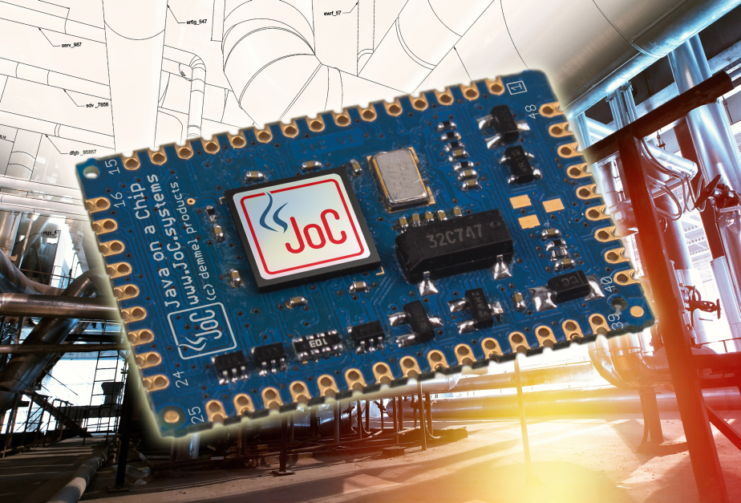

PNG image (RGB):
http://www.demmel.com/download/ilcd/press/
Java_Display_Computing_iLCD-Manager+Panel RGB_300dpi.png

TIF image (CMYK):
http://www.demmel.com/download/ilcd/press/
Java_Display_Computing_iLCD-Manager+Panel_CMYK_300dpi.tif

Word file of this press release:
https://www.demmel.com/download/ilcd/press/
20190226_demmel_joc_pr_en.doc

Press contact:
Wolfgang Aichberger
marketing@demmel.com

Agentur Lorenzoni Public Relations
Beate Lorenzoni
+49 8122 55917-22
beate@lorenzoni.de

